‘Piss on Pity’: An Exploration into Bristol and Disability Activism
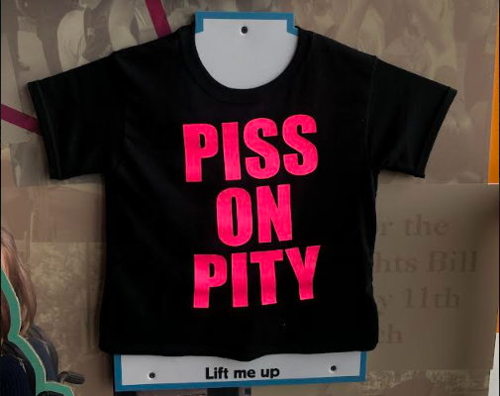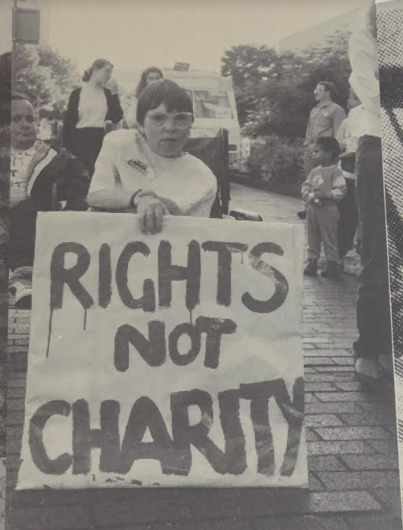
From the 1980s until the present day, there have been a series of movements and actions from disabled people in Bristol. However, their narratives appear to be almost invisible in academic articles and even in the archives of Bristol. Currently, there is a small exhibition in MShed that opened in October 2022 until October 2023, which is in collaboration with the Bristol Disability Equality Forum. The themes, design and feel of the museum display have all been guided by the experience of disabled young people. This exhibition acted as a foundation for this research, due to the sheer lack of evidence elsewhere, which speaks volumes to the attention that these narratives have received.
The Disabled People’s Movement occurs on a wide scale, from focusing on language, to everyday actions, to larger demonstrations. However, all follow the same ethos, to ‘piss on pity’.
Language has become a foundational area for the Disabled People’s Movement to take place. This firstly happens with terming themselves as ‘Disabled people’ rather than ‘people with disabilities’. The rejection of ‘people with disabilities’ stems from a dislike of being viewed as a person with a medical issue that has to be pitied. Focusing on their medical issue leads to the responsibility of this placed on the person, and more importantly society’s refusal to not cater for them.
A key group that must be mentioned is the Avon Coalition of Disabled People, that act to make Bristol more ableist. Disability activist and first paid worker for the Avon Coalition of Disabled People, Penny Germon, wrote that ‘We were making history. We shook Bristol’. This earthquake happened on a multitude of levels but has been quieted through memory. Examples of their protests are 1989, when Arnolfini made their café inaccessible. This was the first instance of protest, as Ian Popperwell (Founding Member of the Avon Coalition of Disabled People) wrote how ‘It was the first time that disabled people were being publicly angry’. Popperwell continued to say that this anger arose from the fact that ‘the people that talk to me in a different kind of voice if I go into a shop, are in about the same proportion as they were where I was a child’. Due to this, the coalition had a demonstration outside.
However, this simply scratches the surface of the Disabled People’s Movement. A fascinating area of the movement that appears to be fully absent, aside from the MShed exhibition, were the Anti-Children in Need protests in the early 1990s. In 1980, BBC aired the first Children in Need telethon to raise money. However, the intentions of the BBC were protested against. Alan Holdsworth told The Independent in 1992 that Children in Need ‘portrays us as tragic, pathetic victims who long to be non-disabled, or plucky heroes who deserve a pat on the head for triumphing over adversity’. The demonstration, called ‘Block Telethon’, included individuals wearing t-shirts, with the phrase ‘Piss on Pity’ emblazoned across the chest. This is mostly remembered to have occurred in London on Tuesday 7th July 1992. Yet, the narrative in Bristol has been obscured. The Avon Coalition of Disabled People played a vital role in this, as well as the West of England Coalition of Disabled People. David Mendelsohn shared in 1991 that there was a ‘sort of pre-launch event’ on Whiteladies Road, as people were marching outside the studio centre in Bristol. What began as a march, led to a blockade, as demonstrators locked arms and blocked Whiteladies Road, as well as putting up banners challenging Children in Need. Mendelsohn furthered that this happened for a ‘good few minutes’, but then ‘the cavalry were mustered’. A more graphic story of this event comes from Alun Davies, who went on these demonstrations, but was punched in the face and told not to be ‘such an ungrateful bastard’. Davies argued that this was because they did not like the charitable approach being challenge, but Davies saw this charitable approach as opposing the self-determination of Disabled people.
The Anti-Children in Need demonstrations are vastly revealing for the attitude towards disabled people in Bristol. This is shown both in the events, but also memory. The ‘cavalry’ brought against the demonstrators, and Davies getting punched in the face establishes that Bristol does not truly understand the aims and concerns of Disabled people. However, what speaks higher volumes, is the absence of this in historical articles, and more importantly the Bristol Archives.
Are Bristol ashamed of the Disabled People’s Movement?
Are they concerned that the Anti-Children in Need demonstration makes them appear uncharitable?
Furthermore, has anything changed since the 1990s demonstrations? Arguably, little. Laura Welti (Disability activist and forum manager for the Bristol Disability Equality Forum) spoke how in 2010, that there was a view of Disabled people being ‘idle scroungers’, which led to a rise in hate crime. Welti recalls being in a café, where someone said, ‘Do you need that? Can’t you walk at all?’, in regard to her mobility scooter. This language evidences a continued lack of sympathy from Bristolian society in the 2010s. Welti does see that things are slowly changing. However, this is emerging from Disabled people themselves, rather than relying on other companies. An example of this is PROPS, a Bristol business, that supports adults with learning disabilities. PROPS has a network of businesses in Bristol, such as the Vassall Centre Café. This café is staffed by adults with learning disabilities, which acts to target barriers within the workplace.
Throughout the Disabled People’s Movement since the 1980’s, there has been an ongoing theme of rejecting the pity narrative. This first took place through demonstrations that targeted companies to become more ableist. However, recently this desire has led to disabled people taking matters in to their own hands, as shown by PROPS.
A key takeaway from this research is to question why demonstrations, such as the Anti-Children in Need protest, has been hidden in Bristol’s past? It begs the question of whether Bristolians are ashamed of appearing as uncharitable. On a wider scale, it makes one think about how beneficial Children in Need is in actually boosting the lives of disabled people.
Disabled People are not to be pitied on and are not simply a charity bucket. All they want are their own rights.

